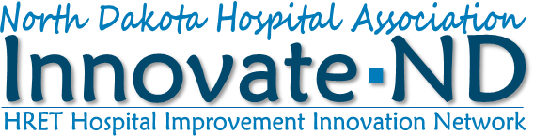
Rapid Action
Readmission Reduction Collaborative Toolkit

Innovate-ND
Mini RCA Readmission Process Improvement Discovery Tool (Excel)

Deployment Checklist

HRET HIIN

HRET HIIN Readmission Reduction Resources
These resources and tools are designed to help hospitals make patient care safer and improve care transitions. Included are the Readmissions Change Package | 2018 which provides a menu of strategies, change concepts and specific actionable items and the Readmissions Data Collection Fact Sheet, a valuable reference for data collection and reporting.

CMS Discharge Planning Checklist
This tool provides a checklist of discharge elements that CMS states should be provided to all Medicare and Medicaid patients. This tool can be used to update existing processes and identify whether new processes and practices need to be implemented. Updated by the Centers for Medicare and Medicaid (CMS) in March 2019.

ASPIRE Tool 2: Readmission Review Tool
This tool includes a readmission interview guide and root cause analysis to assist quality improvement and clinical staff in understanding the patient or caregiver’s perspective about readmissions.

Getting There Guide: Engage the Right People on Your Performance Improvement Journey
The Getting There Guide dives into engagement of staff within the hospital and understanding who and how to engage or connect in an effective way.

ND HRET HIIN Participating Hospitals
Linton Patient Follow-up Call Policy

Linton Patient Follow-up Call Form

Sakakawea Follow-up Phone Call Template

Presentation Medical Center Admissions Packet:
- PMC Community Resource Guide
- PMC Your Daily Routine in the Hospital
- PMC Questions to Ask before Discharge

Presentation Medical Center Daily Rounds Worksheet

Honoring Choices
www.honoringchoicesnd.org
Advance care planning resources and training opportunities.

Institute for Healthcare Improvement (IHI)
“Conversation Ready”: A Framework for Improving End-of-Life Care
Very effective white paper for improving end of life care within a health system.

Great Plains QIN
Teach-Back Toolkit
A self-study guide for healthcare professionals that provides education around teach-back, a communication technique used to help patients remember and understand the important information regarding their diagnosis, treatment, or medication.

Improving End of Life Care: Eating the Elephant One Bite at a Time
Recorded advance care planning LAN event based on IHI’s principle; includes provider stories.

Partnership for Clear Health Communication
Ask Me 3
Patient education tool highlighting questions patients should ask every time they talk with their doctor, nurse or pharmacist.

American Geriatrics Society

2019 American Geriatrics Society Beers Criteria® for Potentially Inappropriate Medication Use in Older Adults

