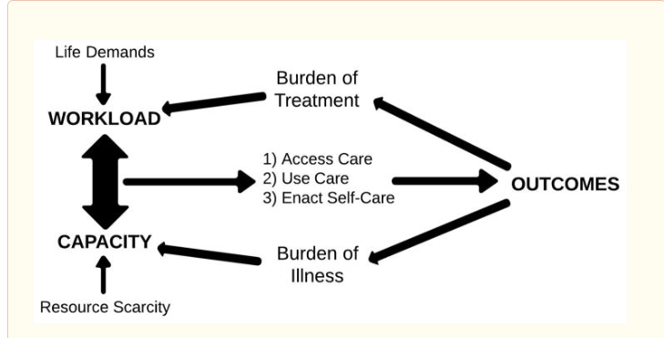
Readmissions Action Plan Template
Overall Goal

Interventions | Smart Goal  Specific, Meaningful, Action oriented, Realistic, Timeline | Team Members  (specific) | Community Partners | Resources
1.

2.

3.

4.

5.

